Client-Server Systems

Definition
# Source: Chatgpt (GPT-5-Mini) at [1/16/2026]
A Client-Server System is a type of distributed system where:
- Clients request services or resources.
- Servers provide those services or resources.
It follows a centralized model: the server is the main authority, and clients depend on it to perform tasks.

Architecture Diagram
# Source: Chatgpt (GPT-5-Mini) at [1/16/2026]
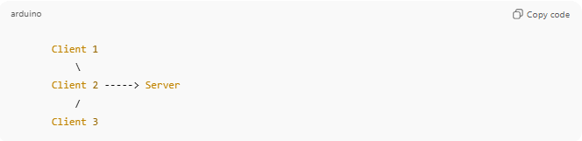
Client 1
\
Client 2 -----> Server
/
Client 3
Explanation:
- Multiple clients can connect to the same server.
- The server handles requests and sends responses back.
- Clients usually don’t communicate directly with each other.

Key Features
# Source: Chatgpt (GPT-5-Mini) at [1/16/2026]
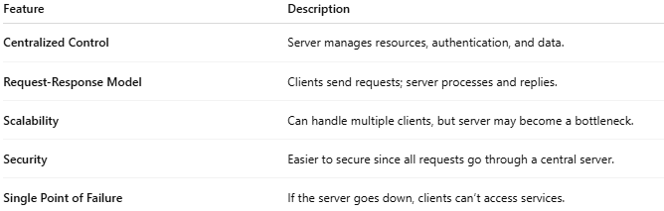
Feature | Description
Centralized Control | Server manages resources, authentication, and data.
Request-Response Model | Clients send requests; server processes and replies.
Scalability | Can handle multiple clients, but server may become a bottleneck.
Security | Easier to secure since all requests go through a central server.
Single Point of Failure | If the server goes down, clients can’t access services.

Types of Client-Server Systems
# Source: Chatgpt (GPT-5-Mini) at [1/16/2026]
- Two-tier
  - Client ↔ Server
  - Example: Database client accessing MySQL server.
- Three-tier / Multi-tier
  - Client ↔ Application Server ↔ Database Server
  - Example: Online shopping app (frontend → app server → database).

Real-World Examples
# Source: Chatgpt (GPT-5-Mini) at [1/16/2026]
- Web servers: Chrome or Firefox requests web pages from a server.
- Email servers: Gmail server handles sending/receiving emails for clients.
- Online banking: ATM or mobile app communicates with the bank server.
- File servers: Corporate network where files are stored on a central server.

Advantages
# Source: Chatgpt (GPT-5-Mini) at [1/16/2026]
- Centralized management and control
- Easier to maintain security
- Easier to update applications (update server → all clients benefit)

Disadvantages
# Source: Chatgpt (GPT-5-Mini) at [1/16/2026]
- Server can become a bottleneck if many clients request at the same time
- Single point of failure
- Less fault-tolerant than decentralized systems (like P2P)

💡 Analogy
# Source: Chatgpt (GPT-5-Mini) at [1/16/2026]
Think of a restaurant:
- Server = the chef and kitchen (prepares food)
- Clients = customers (place orders)
- The chef must prepare food for each customer. If the kitchen closes, no one gets food.

